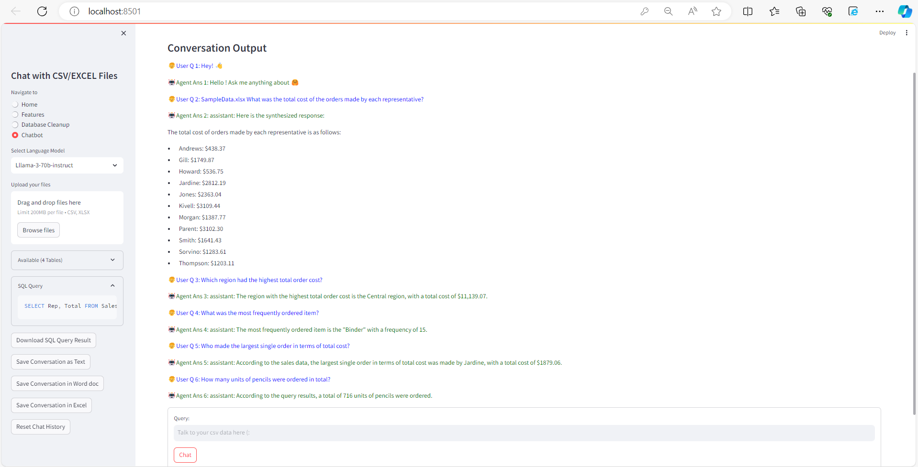

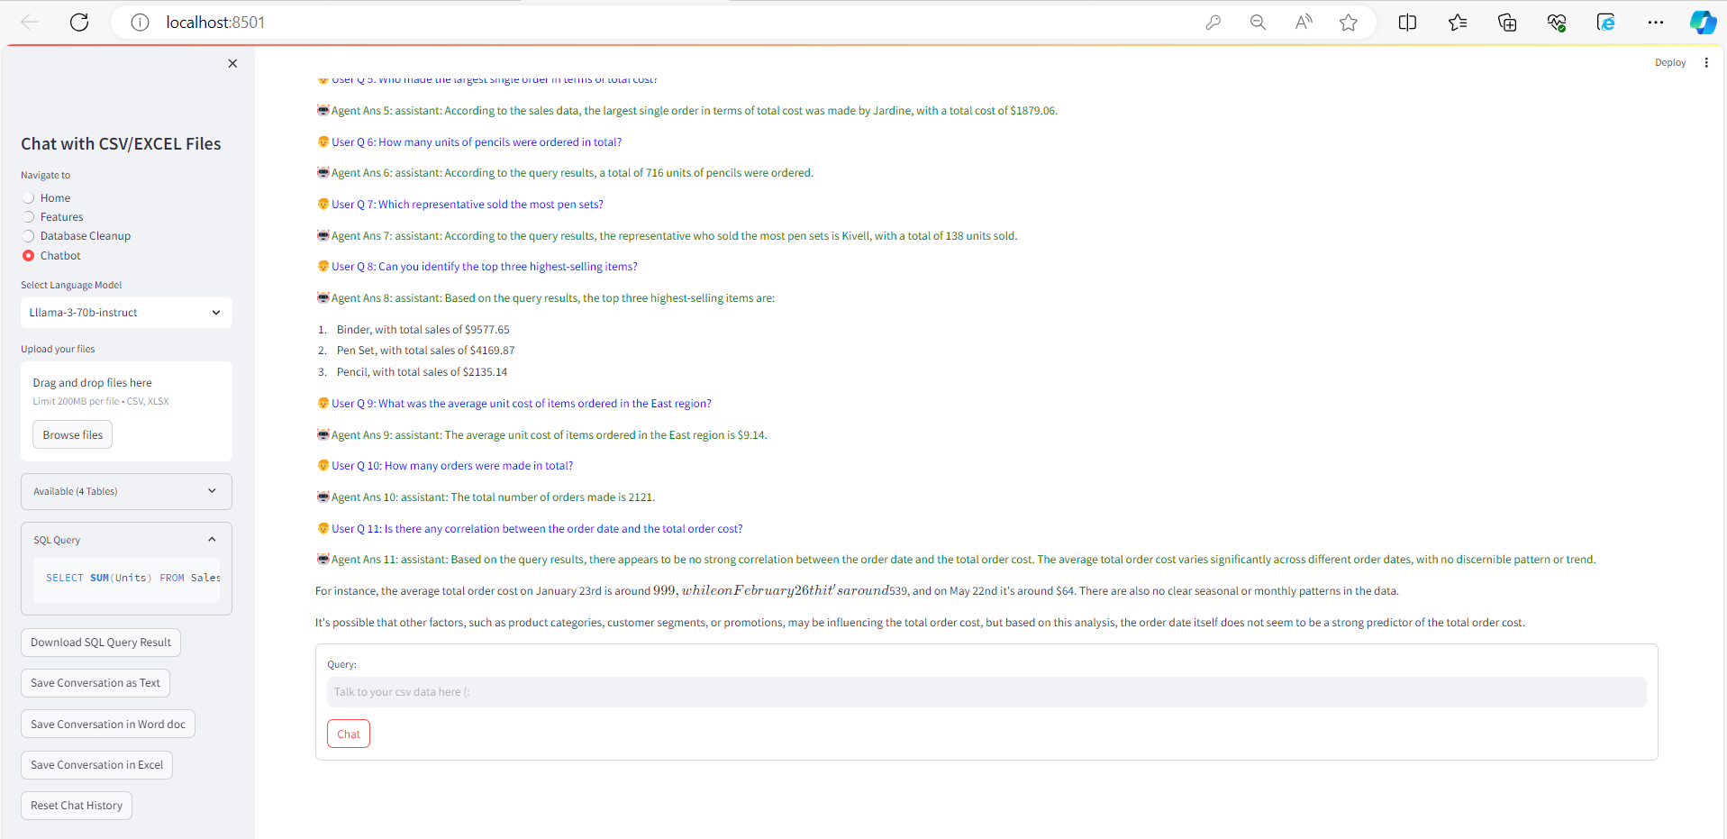



**Prompts:**

What was the total cost of the orders made by each representative?

Which region had the highest total order cost?

What was the most frequently ordered item?

Who made the largest single order in terms of total cost?

How many units of pencils were ordered in total?

Which representative sold the most pen sets?

Can you identify the top three highest-selling items?

What was the average unit cost of items ordered in the East region?

How many orders were made in total?

Is there any correlation between the order date and the total order cost?